Proceedings of
The 4th National Meeting on Biodiversity Management in Thailand
การประชุมวิชาการการบริหารจัดการความหลากหลายทางชีวภาพแห่งชาติ ครั้งที่ 4 (2017) : XX-XX
ชื่อเรื่อง (TH SarabunSPK 16 bold, before 12 after 10 pt, multiple line 1, center)
ชื่อผู้เขียนคนแรก (หากเป็นคนเดียวกับผู้รับผิดชอบบทความ ให้ลงท้ายเลขหนึ่ง และ เครื่องหมาย *)^{1,*}, ชื่อผู้ร่วมเขียน²,
ชื่อผู้ร่วมเขียนคนสุดท้าย³ ขึ้นบรรทัดใหม่ ใช้ shift + enter ระหว่างผู้เขียนก่อนคนสุดท้ายและคนสุดท้ายไม่มี “และ” ใช้เพียง “,” เท่านั้น (TH SarabunSPK 13) bold, before 10 after 10 pt, single line, center)
¹ที่อยู่ผู้เชียนคนแรก
²ที่อยู่ผู้เชียนคนที่สอง
³ที่อยู่ผู้เขียนคนสุดท้าย
ที่อยู่ให้เขียน ชื่อภาควิชาหรือชื่อหน่วยย่อยของสถาบัน, ชื่อสถาบัน, ที่อยู่ประกอบด้วย เขต, จังหวัด, รหัสไปรษณีย์
ที่อยู่แต่ละส่วนคั้นด้วยเครื่องหมาย “,” (TH SarabunSPK 13), before 10 pt, single line, center)
shift+enter สำหรับขึ้นบรรทัดใหม่
อีเมลล์ผู้รับผิดชอบบทความ : ใส่ email ผู้รับผิดชอบบทความของผู้ที่มีเครื่องหมาย * ตามหลังชื่อ
บทคัดย่อ : ไม่เกิน 250 คำ (TH SarabunSPK 13), single line) ไม่ย่อหน้า มีเพียงหนึ่ง paragraph เท่านั้น......................................................................................................................................................................................................................
......................................................................................................................................................................................................................
......................................................................................................................................................................................................................
......................................................................................................................................................................................................................
......................................................................................................................................................................................................................

คำสำคัญ : 5 คำ (TH SarabunSPK 13, after 8 pt, multiple line 1.08 pt) คำสำคัญไม่ควรซ้ำกับชื่อหัวเรื่อง
Title in English (TH SarabunSPK 13, single line)
Author name (TH SarabunSPK 13, single line)
Address = department, Institute or University, Destrict, Province, post code (TH SarabunSPK 13, single line)

Corresponding author e-mail: replace corresponding email
Abstract: less than 250 words, only 1 paragraph (TH SarabunSPK 13, single) ………………………………………………………….......
......................................................................................................................................................................................................................
......................................................................................................................................................................................................................
......................................................................................................................................................................................................................
......................................................................................................................................................................................................................
......................................................................................................................................................................................................................
......................................................................................................................................................................................................................
......................................................................................................................................................................................................................
Keywords : only 5 word, shouldn’t include the word in title
บทนำ/Introduction
(TH SarabunSPK 16) bold, before 10 after 10 pt, single line, center)
(TH SarabunSPK 13, before 10 pt, after 10 pt, single line, first line indent 1.27, ขึ้นบรรทัดใหม่ ใช้ shift + enter) …………………………………………..…………………………………………..…………………………………………..…………………………………………..
............................................................................................................................................................................................................................................................................................................................................................................................................................................................................................................................................................................................................................................................................................................................................................................................................................................................................................................................................................................................................................................................................................................................................................................................................................................................................................................................................................................................................................................................................................................................................................................................................................................................................................................................................................................................................................................................................................................................................................................................................................................................................................................................................................................................................................
วิธีการ or Material and Method
(TH SarabunSPK 16) bold, before 10 after 10 pt, single line, center)
(TH SarabunSPK 13, before 10 pt, after 10 pt, single line, first line indent 1.27, ขึ้นบรรทัดใหม่ ใช้ shift + enter) …………………………………………..…………………………………………..…………………………………………..…………………………………………..
............................................................................................................................................................................................................................................................................................................................................................................................................................................................................................................................................................................................................................................................................................................................................................................................................................................................................................................................................................................................................................................................................................................................................................................................................................................................................................................................................................................................................................................................................................................................................................................................................................................................................................................................................................................................................................................................................................................................................................................................................................................................................................................................................................................................................................
ผลการศึกษา or Result & Discussion
(TH SarabunSPK 16) bold, before 10 after 10 pt, single line, center)
(TH SarabunSPK 13, before 10 pt, after 10 pt, single line, first line indent 1.27, ขึ้นบรรทัดใหม่ ใช้ shift + enter) …………………………………………..…………………………………………..…………………………………………..…………………………………………..
............................................................................................................................................................................................................................................................................................................................................................................................................................................................................................................................................................................................................................................................................................................................................................................................................................................................................................................................................................................................................................................................................................................................................................................................................................................................................................................................................................................................................................................................................................................................................................................................................................................................................................................................................................................................................................................................................................................................................................................................................................................................................................................................................................................................................................
(TH SarabunSPK 13, before 10 pt, after 10 pt, single line, first line indent 1.27, ขึ้นบรรทัดใหม่ ใช้ shift + enter) …………………………………………..…………………………………………..…………………………………………..…………………………………………..
............................................................................................................................................................................................................................................................................................................................................................................................................................................................................................................................................................................................................................................................................................................................................................................................................................................................................................................................................................................................................................................................................................................................................................................................................................................................................................................................................................................................................................................................................................................................................................................................................................................................................................................................................................................................................................................................................................................................................................................................................................................................................................................................................................................................................................
1)………………................................................................................................................................................................................. .......................................................................................................................................................................................................................................................................................................................................................................................................................................................................................................................................................................................................................................................................................................................................................................................................................................................................
บทสรุป or Conclusion
(TH SarabunSPK 16) bold, before 10 after 10 pt, single line, center)
(TH SarabunSPK 13, before 10 pt, after 10 pt, single line, first line indent 1.27, ขึ้นบรรทัดใหม่ ใช้ shift + enter) …………………………………………..…………………………………………..…………………………………………..…………………………………………..
............................................................................................................................................................................................................................................................................................................................................................................................................................................................................................................................................................................................................................................................................................................................................................................................................................................................................................................................................................................................................................................................................................................................................................................................................................................................................................................................................................................................................................................................................................................................................................................................................................................................................................................................................................................................................................................................................................................................................................................................................................................................................................................................................................................................................................
(TH SarabunSPK 13, before 10 pt, after 10 pt, single line, first line indent 1.27, ขึ้นบรรทัดใหม่ ใช้ shift + enter) …………………………………………..…………………………………………..…………………………………………..…………………………………………..
............................................................................................................................................................................................................................................................................................................................................................................................................................................................................................................................................................................................................................................................................................................................................................................................................................................................................................................................................................................................................................................................................................................................................................................................................................................................................................................................................................................................................................................................................................................................................................................................................................................................................................................................................................................................................................................................................................................................................................................................................................................................................................................................................................................................................................
กิตติกรรมประกาศ or Acknowledgement
(TH SarabunSPK 16) bold, before 10 after 10 pt, single line, center)
(TH SarabunSPK 13, before 10 pt, after 10 pt, single line, first line indent 1.27, ขึ้นบรรทัดใหม่ ใช้ shift + enter) …………………………………………..…………………………………………..…………………………………………..…………………………………………..
.................................................................................................................................................................................................................................................................................................................................................................................................................................................................................................................................................................................................................................................................................................................................................................................................................................................................................................................................................................................................................................................................................................................................................................................................................................................................................................................................................................................................................................................................................................................................................................
เอกสารอ้างอิง or References
(TH SarabunSPK 16) bold, before 10 after 10 pt, single line, center)
หากเป็นภาษาไทย TH SarabunSPK 12, Hanging 1 cm, ชื่อนามสกุลผู้เขียนเต็ม คันด้วยเครื่องหมาย “,” ก่อนคนสุดท้าย เชื่อมด้วย “and” แต่งเกิน 6 คนให้ใช้ “และคณะ” จบชื่อผู้แต่งด้วย “.” จุด ปีพศ. ตามด้วย “.” ชื่อเอกสาร สำนักพิมพ์ เล่มที่(volum) เลขหน้าที่อ้างถึง เครื่องหมายเชื่อมเลขหน้าให้ insert symbol “–“ ทุกเอกสารอ้างอิงเรียงตามตัวอักษรของชื่อ และตามด้วยนามสกุล หากผู้ (ตัวอย่าง)
กาญจนา อดุลยานุโกศล, โสภณ ทองดี, ไพรัตน์ สุธิผล, สุรศักดิ์ ทองสุกดี, สุระชัย ภาสดา และ ธีรวัตร เปรมปรี. 2555. ท่องเที่ยวชมโลมาและปลาวาฬในเมืองไทย. สำนักอนุรักษ์ทรัพยากรทางทะเลและชายฝั่ง
กาญจนา อดุลยานุโกศล, สุรศักดิ์ ทองสุกดี, สุระชัย ภาสดา และ ธีรวัตร เปรมปรี. 2556. วาฬบรูด้าและอ่าวไทยรูปตัว ก. กรมทรัพยากรทางทะเล
และชายฝั่ง
วรปรัชญ์ โยเหลา, ธนวัฒน์ ขวัญบุญ และ ศุภลักษณ์ วิรัชพินทุ. 2558. ศักยภาพของนกและสัตว์ป่า เพื่อการท่องเที่ยวเชิงนิเวศ ประเภทดูนก ตำบล
ชมพู อำเภอเนินมะปราง จังหวัดพิษณุโลก. Proceeding พะเยาวิจัย ครั้งที่ 5 28–29 มกราคม 2559. มหาวิทยาลัยพะเยา.
วีระศักดิ์ กราปัญจะ. 2554. รูปแบบการจัดการท่องเที่ยวเชิงนิเวศในพื้นที่ป่าชุมชน บ้านอ่าวท่าเลน-บ้านป่าพรุ ตำบลเขาทอง อำเภอเมือง จังหวัดกระบี่. วิทยานิพนธ์หลักสูตรศิลปศาสตรมหาบัณฑิต สาขาวิชาส่งเสริมการเกษตรและสหกรณ์ มหาวิทยาลัยสุโขทัยธรรมาธิราช. ปทุมธานี.
สิรินทิพย์ พันธ์มัฆวาฬ. 2552.การพัฒนาและการจัดการการท่องเที่ยวเชิงนิเวศวัฒนธรรมจังหวัดมหาสารคาม. วิทยานิพนธ์หลักสูตรศิลปศาสตรมหาบัณฑิต สาขาวิชาวัฒนธรรมศาสตร์ มหาวทิยาลัยมหาสารคาม. มหาสารคาม.

หากเป็นภาษาอังกฤษ TH SarabunSPK 12, Hanging 1 cm, “นามสกุล, ชื่อย่อตามด้วยจุด” ชื่อแต่คนคันด้วยเครื่องหมาย “,” ก่อนคนสุดท้าย เชื่อมด้วย “and” แต่งเกิน 6 คนให้ใช้ “et. al.” จบชื่อผู้แต่งด้วย “.” จุด ปีคศ. ตามด้วย “.” ชื่อเอกสาร สำนักพิมพ์ เล่มที่(volum) เลขหน้าที่อ้างถึง เครื่องหมายเชื่อมเลขหน้าให้ insert symbol “–“ ทุกเอกสารอ้างอิงเรียงตามตัวอักษรของนามสกุล และชื่อย่อ และปี (ตัวอย่าง) การอ้างเวปไซด์ให้ใส่ข้อมูลเพิ่ม วันที่ๆ เข้าถึงเวปนั้นต่อท้ายที่อยู่ของ เวปไซด์
Amante-Helweg, V. 1996. Ecotourists' beliefs and knowledge about dolphins and the development of cetacean ecotourism. Aquatic Mammals 22(2) 131–140.
Beasley, I.., Bejder, S., and Marsh, E. 2010. Dolphin-watching tourism in the Mekong River, Cambodia: a case study of economic interests influencing conservation. Report to the International Whaling Commission SC/62/WW4.
D'Lima, C., Welters, R., Hamann, M., and Marsh, H. 2016. Using regional geographic scale substitution to value coastal wildlife tourism: Implications for stakeholders, conservation and management. Ocean & Coastal Management 128: 52–60.
Hu, W., Boehle, K., Cox, L., and Pan, M. 2009. Economic values of dolphin excursions in Hawaii: A stated choice analysis. Marine Resource Economics 24(1) 61–76.
Hughes, P. 2001. Animals, values and tourism—structural shifts in UK dolphin tourism provision. Tourism Management
22(4) 321–329.
Jaroensutasinee, M., Jutapruet, S., and Jaroensutasinee, K. 2011. Population Size of Indo-Pacific Humpback Dolphins (Sousa chinensis) at Khanom, Thailand. Walailak Journal of Science and Technology (WJST) 7(2) 115–126.
Jutapruet, S., K. Kittiwattanawong, and Pradit, S. 2014. A survey of Dolphin sightings experienced by local fishermen in Donsak District, Surat Thani Province, Proceeding of the 1st Environment and Natural Resources International Conference (ENRIC 2014), Bangkok, November 6th-7th, 2014, Bangkok, Thailand p. 180–188.
Jutapruet, S., K. Kittiwattanawong, and Pradit, S. 2014. Population size and habitat patterns of Indo-Pacific Humpback Dolphins (Sousa chinensis) in Donsak, Surat Thani, Thailand, Chiang Mai Journal of Science 41(1) 136–147.
Jutapruet, S., Shiang-Lin, H., Li, S., Lin, M, Kittiwattanawong, K, and Pradit, S. 2014 Population size and habitat characteristics of the Indo-Pacific humpback dolphins (Sousa chinensis) off Donsak, Surat Thani, Thailand, Aquatic Mammal
41(2) 129–142.
Lusseau, D., and Higham, J. E. S. (2004). Managing the impacts of dolphin-based tourism through the definition of critical habitats: the case of bottlenose dolphins (Tursiops spp.) in Doubtful Sound, New Zealand. Tourism Management 25(6) 657–667.
Mustika, P. L. K., Birtles, A., Welters, R., and Marsh, H. 2012. The economic influence of community-based dolphin watching on a local economy in a developing country: Implications for conservation. Ecological Economics 79: 11–20.
O’Connor, S., Campbell, R., Cortez, H., and Knowles, T. 2009. Whale Watching Worldwide: tourism numbers, expenditures and expanding economic benefits, a special report from the International Fund for Animal Welfare. Yarmouth MA, USA, prepared by Economists at Large p 228.
Orams, M. B. 1996. A conceptual model of tourist‐wildlife interaction: the case for education as a management strategy. The Australian Geographer 27(1) 39–51.
Orams, M. B. 2002. Feeding wildlife as a tourism attraction: a review of issues and impacts. Tourism management
23(3) 281–293.
Parsons, E. C. M., Warburton, C. A., Woods‐Ballard, A., Hughes, A., and Johnston, P. 2003. The value of conserving whales:
the impacts of cetacean-related tourism on the economy of rural West Scotland. Aquatic Conservation: Marine and Freshwater Ecosystems 13(5) 397–415.
Piwetz, S., Hung, S., Wang, J., Lundquist, D., and Würsig, B. 2012. Influence of vessel traffic on movements of Indo-Pacific humpback dolphins (Sousa chinensis) off Lantau Island, Hong Kong. Aquatic Mammals 38(3) 325.
Samuels, A., and Bejder, L. 2004. Chronic interaction between humans and free-ranging bottlenose dolphins near Panama City Beach, Florida. Journal of Cetacean Research and Management 6(1) 69–77.
Tseng, Y. P., Huang, Y. C., Kyle, G. T., and Yang, M. C. 2011. Modeling the impacts of cetacean-focused tourism in Taiwan: observations from cetacean watching boats: 2002–2005. Environmental management 47(1) 56–66.
Van Parijs, S. M., and Corkeron, P. J. 2001. Boat traffic affects the acoustic behaviour of Pacific humpback dolphins, Sousa chinensis. Journal of the Marine Biological Association of the UK 81(03) 533–538.

คำแนะนำเพิ่มเติม
1. หากผู้เขียนใช้ภาษาไทยทั้งบทความ ให้แทรกบทคัดย่อพร้อมชื่อที่อยู่ผู้เขียน และ email ของผู้รับผิดชอบบทความดังตัวอย่างข้างต้น
2. หากผู้เขียนใช้ภาษาอังกฤษทั้งบทความ ไม่ต้องแรกบทคัดย่อภาษาไทย

วิธีการใส่ข้อมูลตารางและภาพ
1. ให้ใส่ตารางและภาพด้านหลังเอกสารอ้างอิงทั้งหมด ห้ามแทรกในเนื้อหา และใช้คำอ้างอิงในเนื้อหาว่า “ตารางที่ 1” หรือ “ภาพที่ 1” หรือ “แผนภูมิที่ 1” เป็นต้น
2.

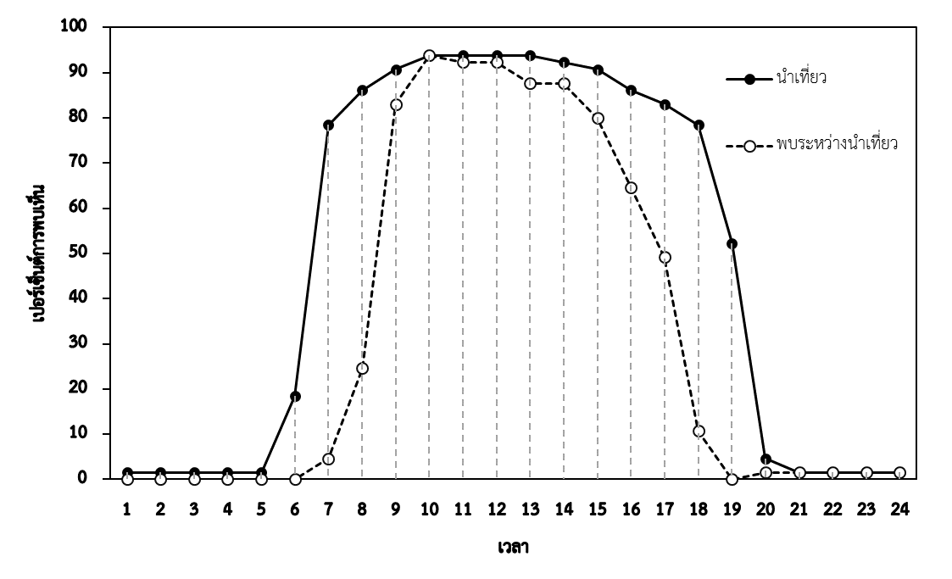
ภาพที่ 1  ร้อยละของชาวประมงที่พบในช่วงเวลาการนำเที่ยวชมโลมาและวาฬ และ  ช่วงเวลาที่พบโลมาและวาฬในการนำเที่ยว
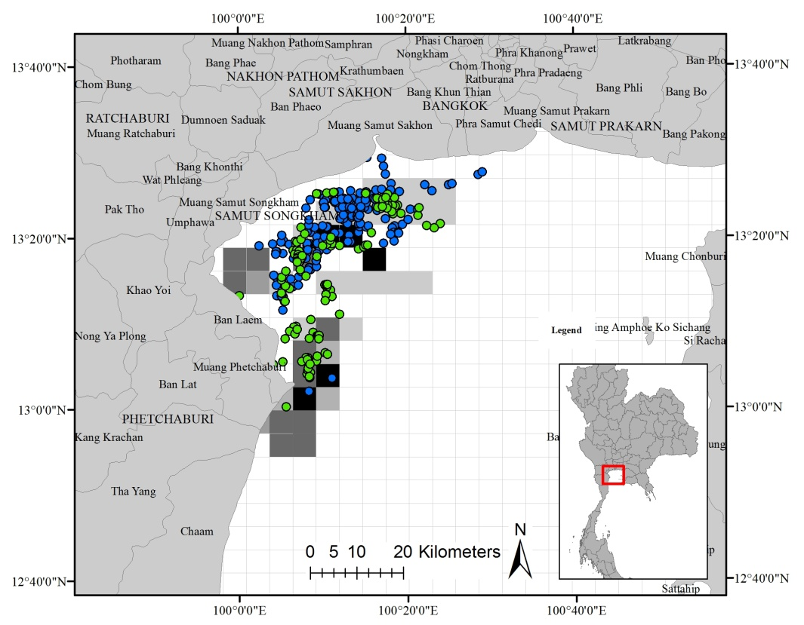
ภาพที่ 2  ร้อยละของความถี่การพบเห็นวาฬและโลมาจากประสบการณ์ของชาวประมงในพื้นที่ และข้อมูลการอนุเคราะห์จาก
Wild Encounter Thailand  ข้อมูลปีพ.ศ.2557  ข้อมูลปีพ.ศ.2558 จุดให้บริการนำเที่ยวชมวาฬ
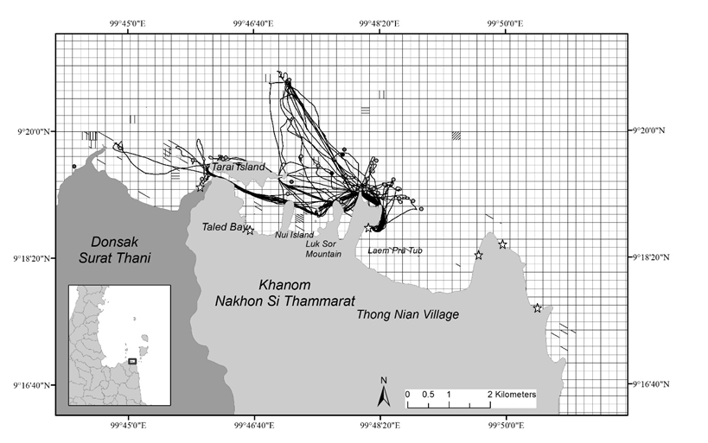
ภาพที่ 3 ร้อยละของความถี่การพบเห็นโลมาแต่ละชนิดจากประสบการณ์ของชาวประมงในพื้นที่ (สัญลักษณ์ \ คือ โลมาหลังโหนก / คือ วาฬบรูด้า | คือ โลมาอิรวดี – โลมาหัวบาตรหลังเรียบ) และการบันทึกข้อมูลจาก GPS โดยตัวแทนชาวประมง อำเภอขนอม จังหวัดนครศรีธรรมราชและอำเภอดอนสัก จังหวัดสุราษฎร์ธานี จุดให้บริการนำเที่ยวชมโลมา
- เส้นทางนำเที่ยวโดยเรือชาวประมง  จุดที่พบโลมาโดยการนำเที่ยวของชาวประมง

